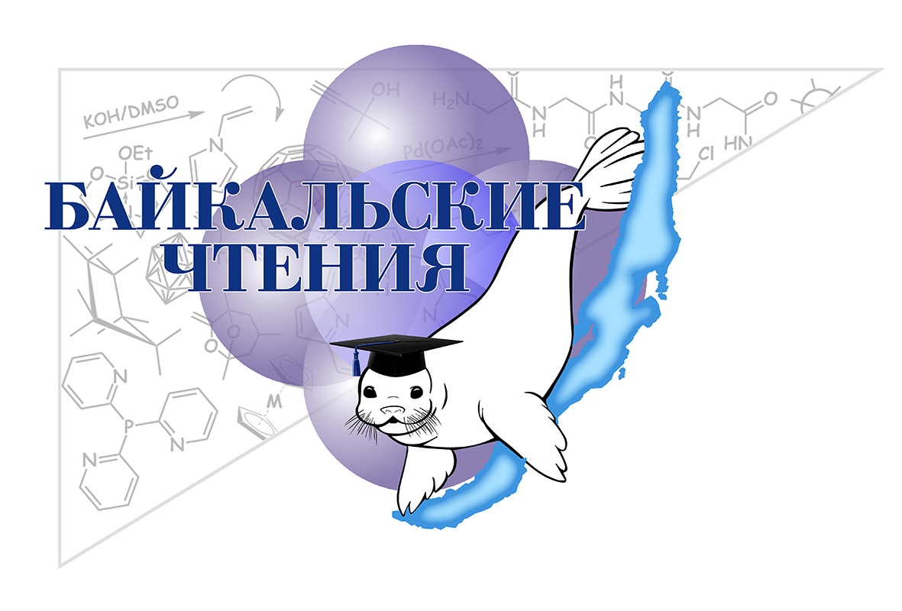
Registration number
(filled by the Organizing Committee)

Conference website
Baikal conference - 2017

REGISTRATION FORM OF THE PARTICIPANT
Last name:
First Name:
Middle name:
Birthday:
Full name of organization:
Short name of organization:
Address of organization:
Status of participant
(student/PhD student/young scientist):
Scientific degree:
Phone:
E-mail:
Title of the presentation:
Authors:
Type of participation (standard/by correspondence):
Type of presentation (oral/poster):
Accommodation: room type, number of persons (additional information is attached)*:
Number of accompanying persons:
Names of accompanying persons:
* Room type can be chosen online at www.elochka-otel.ru/ or at the conference website

The filled registration form should be sent to baikalchem_2017@irioch.irk.ru.

